Annexure3b- Complete filing

INVENTION DISCLOSURE FORM

Details of Invention for better understanding:

1. TITLE: A Geo-Tagged Environmental Issue Reporting System with Incentive-Based Participation and NGO-Integrated Sustainable Marketplace

2. INTERNAL INVENTOR(S)/ STUDENT(S): All fields in this column are mandatory to be filled
A. Full name | _{Shivang Chaurasia}
Mobile Number | 9660967612
Email (personal) | shiva17ng@gmail.com
UID/Registration number | 12316885
Address of Internal Inventors | Lovely Professional University, Punjab-144411, India
Signature (Mandatory) | 

B. Full name | _{Riya}
Mobile Number | 7906411379
Email (personal) | briya1597@gmail.com
UID/Registration number | 12316877
Address of Internal Inventors | Lovely Professional University, Punjab-144411, India
Signature (Mandatory) | 
C. Full name | Himanshu Shekhar
Mobile Number | 7250213466
Email (personal) | himanshushekharon@gmail.com
UID/Registration number | 12318302
Address of Internal Inventors | Lovely Professional University, Punjab-144411, India
Signature (Mandatory) | 

D. Full name | _{Vaibhav Nanda}
Mobile Number | 9878169977
Email (personal) | vaibhavnanda2000@gmail.com
UID/Registration number | 34462
Address of Internal Inventors | Lovely Professional University, Punjab-144411, India
Signature (Mandatory) | 

E. Full name | _{Dr. Shilpa Sharma}
Mobile Number | 9888679493
Email (personal) | shilpa.sharma@lpu.co.in
UID/Registration number | 13891
Address of Internal Inventors | Lovely Professional University, Punjab-144411, India
Signature (Mandatory) | 

3. DESCRIPTION OF THE INVENTION:
This invention introduces a centralized digital platform engineered to capture, report, and resolve environmental issues in real-time. We built the system as a cross-platform web and mobile application supported by a scalable cloud architecture. It binds together location-based reporting APIs, a multi-tier data validation pipeline, a custom reward engine, and an integrated eco-marketplace into a single functional environment.
On the client side, users encountering environmental hazards—such as illegal dumping, pollution, or animal distress—can instantly document the scene. The application accesses native device hardware to extract precise geographic coordinates (latitude/longitude) alongside image or video uploads. To prevent spam and ensure data integrity, the backend routes every submitted payload through a structured verification process. This involves a combination of peer-to-peer community consensus and authoritative validation from designated organizations.
To solve the historical problem of low civic engagement, a token-based reward system is hardcoded into the platform's workflow. When a user's report passes verification, the system automatically allocates digital credits to their secure wallet. Rather than serving as mere virtual points, these credits hold tangible value within the application's native e-commerce module. Users can redeem their tokens to purchase sustainable, eco-friendly goods supplied exclusively by registered NGO partners. This creates a direct, sustainable revenue stream for local green initiatives.
At the infrastructure level, the system relies on dynamic geospatial tagging and secure cloud databases, with architectural flexibility to integrate AI-driven image classification for automated report validation in the future.
Ultimately, this architecture bridges the gap between everyday citizens, NGOs, and administrative bodies. By linking civic duty directly with measurable economic incentives, the platform transforms passive observers into active participants and creates a self-sustaining ecosystem for environmental monitoring.

- PROBLEM ADDRESSED BY THE INVENTION:

Citizens frequently encounter urgent environmental and humanitarian issues on the ground—from illegal waste dumping to injured animals. While individuals are often willing to help, they rarely know the correct channels or authorities to contact. This friction turns willingness into complete inaction.
The core technical gap is that current reporting systems are heavily fragmented. They rely on outdated complaint portals that lack native device integration for precise geo-tagging or automated media uploads. Even when a citizen manages to submit a report, the data effectively enters a black box. Without real-time status tracking, users cannot verify if corrective action was taken. This lack of transparency quickly erodes trust and discourages future participation.
Beyond the technical friction, existing platforms fail to account for user motivation. Civic duty alone is rarely enough to sustain consistent engagement. Because there is no tangible incentive model to reward verified reporting, public participation remains unsustainably low.
On the other side of this ecosystem are the non-governmental organizations (NGOs) actively working to solve these environmental and welfare issues. These organizations constantly struggle with visibility and funding. Currently, civic reporting tools and eco-commerce platforms operate in total isolation. There is no data bridge connecting the citizens who identify problems with the organizations capable of solving them, nor is there a pathway for users to financially support those initiatives.
We need an architecture that collapses these silos. The proposed system bridges this gap by combining geospatial reporting, transparent tracking, and a tokenized reward system that feeds directly into an integrated NGO marketplace. This converts passive public concern into a measurable, economically sustainable cycle of environmental action.

- OBJECTIVE OF THE INVENTION:

- Real-Time Geo-Spatial Reporting: Establish a robust reporting framework that captures precise location data and multimedia evidence, allowing users to accurately document on-field environmental issues as they occur.

- Frictionless Public Participation: Drive community engagement through a highly intuitive and accessible interface designed to remove technical barriers and simplify the submission process.

- Multi-Tiered Data Validation: Ensure the authenticity of all submissions by routing reports through a rigorous verification pipeline, combining community consensus with official validation from authorized organizations.

- Incentive-Driven Engagement: Sustain long-term user participation via a built-in reward engine that allocates digital credits to individuals for contributing valid, actionable environmental data.

- Integrated Sustainable Marketplace: Connect the reporting ecosystem to an eco-commerce platform, enabling users to exchange their earned digital credits for environmentally friendly goods supplied by registered NGO partners.

- End-to-End Transparency: Foster accountability by granting users full visibility into the lifecycle of their submissions, allowing them to track the status and resolution progress of reported issues in real-time.

C. STATE OF THE ART/ RESEARCH GAP/NOVELTY:
Sr. No. | Existing System / Patent | Abstract | Research Gap | Novelty
 | Government Complaint Applications (example: Swachh Bharat App, Municipal Portals) | Platforms that allow users to report cleanliness and civic issues to authorities. | Lack of incentive mechanisms for users; limited engagement; absence of integrated reward or economic benefit systems. | Introduces an incentive-based participation model where users are rewarded with redeemable credits for verified environmental reporting.
 | Location-Based Reporting Systems (e.g., Google Maps Issue Reporting) | Enables users to report issues with location tagging and basic descriptions. | No structured verification process; no tracking of issue resolution; lacks integration with environmental or social impact systems. | Implements a multi-layered verification system with community and organizational validation, along with transparent tracking of issue resolution.
 | NGO-Based E-commerce Platforms | Platforms selling eco-friendly or sustainable products created by NGOs. | Operate independently without integration with environmental reporting or user engagement systems. | Integrates NGO-driven marketplaces directly with user participation, allowing credits earned from reporting to be redeemed for eco-products.
 | Smart Civic Engagement Platforms | Systems designed to improve citizen-government interaction for issue reporting. | Limited to complaint handling; no linkage between environmental action and economic incentives; low user retention. | Establishes a closed-loop ecosystem connecting environmental reporting, user incentives, and sustainable commerce within a single platform.

The proposed invention uniquely establishes a closed-loop system integrating geo-tagged environmental issue reporting, multi-level verification, incentive allocation, and NGO-based product redemption within a single unified platform, enabling direct conversion of user-driven environmental actions into measurable economic and social impact.

D. DETAILED DESCRIPTION:
- System Components and Architecture:
The platform is built as a set of interconnected layers designed to move environmental data from the street to a validated resolution state.
- Cross-Platform Client Interface: This is the primary entry point for users—available as both a mobile and web app—where citizens log incidents, track their personal impact, and access the marketplace.
- Automated Spatial Metadata Capture: This module interfaces directly with device GPS hardware to lock in the exact geographical coordinates of a report, ensuring the data is traceable and tamper-resistant.
- Multimedia Evidence Pipeline: Handles the ingestion and processing of image or video files, providing the visual proof necessary for organizations to verify on-field claims.
- The Backend Reporting Engine: Acting as the central processor, this engine organizes raw user data—location, media, and description—into a structured format for storage and analysis.
- Hybrid Verification Pipeline: To ensure reliability, every report undergoes a dual-check process. First, a Community Review allows nearby users to vouch for or flag the report. Second, Authorized Validation allows NGOs or local authorities to give the final confirmation.
- The Logic-Based Reward Engine: Calculates and issues digital credits based on a weighted system of the report's urgency and verified accuracy.
- Secure Digital Wallet & Transaction Ledger: Manages the user’s credit balance and records a history of all earned and redeemed points.
- NGO-Driven Marketplace: A specialized e-commerce environment where partner NGOs list sustainable goods, organic products, and eco-safe items.
- Token Redemption Gateway: The bridge between environmental action and economic value, allowing users to swap their credits for tangible products from the marketplace.
- Cloud-Native Data Infrastructure: A scalable backend that manages the entire database—from user identities to incident reports—ensuring the system stays responsive as the user base grows.
- SYSTEM WORKFLOW (WORKING PROCESS):
The platform’s operational cycle is designed to be frictionless for the user while maintaining high data integrity:
- Incident Detection: A user spots an environmental hazard (like illegal dumping or animal distress) and captures it via the app's camera.
- Automated Tagging: The system syncs with the device's GPS to bind latitude/longitude data to the media file automatically.
- Submission: The user adds a brief context and hits submit, sending the payload to the server.
- Verification Routing: The report is instantly flagged as "Pending" and made visible to the community and relevant NGOs.
- Validation: Local organizations and peer users review the evidence. Once they confirm the issue is real, the report is marked as "Verified".
- Credit Allocation: The reward engine triggers an automatic transfer of digital tokens to the reporter’s wallet based on the report’s verified impact.
- Economic Exchange: The user visits the marketplace and selects an eco-friendly product listed by an NGO.
- Order Fulfilment: The NGO processes the order, completing a cycle where civic reporting directly funds sustainable local businesses.

E. RESULTS AND ADVANTAGES:
This architecture solves the core problems of modern civic engagement through several key advantages:
- Precision in Field Reporting: By mandating geo-tags and media proof, we eliminate the "vague complaint" problem, giving authorities exact data to act upon.
- Sustainable Engagement Levels: Moving beyond "goodwill," the credit system gives users a continuous reason to remain active observers of their environment.
- Breaking the "Black Box" of Government: Real-time tracking gives users a window into the resolution process, building the trust necessary for long-term participation.
- Economic Support for Green NGOs: The platform acts as a new sales and visibility channel for NGOs, helping them generate revenue while solving social issues.
- A Self-Sustaining Loop: By linking reporting, validation, and commerce into one ecosystem, the platform creates a cycle where environmental responsibility pays for itself.

F. EXPANSION:
To move toward a fully automated environmental monitoring network, we plan the following upgrades:
- Computer Vision Integration: Implementing AI to automatically categorize issues (like identifying "plastic waste" vs. "water pollution") from user photos to speed up triage.
- Administrative Dashboard Integration: Building direct APIs for municipal governments so they can receive and resolve reports directly within their internal workflows.
- Immutable Verification via Blockchain: Moving the reward ledger and verification history to a decentralized layer to prevent any possibility of data tampering or fraud.
- Smart City Connectivity: Plugging the system into existing smart city sensors to cross-reference user reports with automated environmental data.
- Marketplace Scaling: Onboarding a wider network of social enterprises to diversify the sustainable products available for redemption

G. WORKING PROTOTYPE/ FORMULATION/ DESIGN/COMPOSITION:
The proposed system is currently in the conceptual and design phase. The overall architecture, workflow, and functional modules have been clearly defined and represented through flowcharts and system design diagrams. The user interface and experience (UI/UX) have been prototyped to ensure a frictionless interaction between citizens reporting issues and the NGOs operating the marketplace.
At the infrastructure level, the platform's architecture is built around the MERN stack (MongoDB, Express.js, React, and Node.js). We structured the system this way to ensure scalable, real-time data handling, which is critical for processing the live geo-tagged media payloads and managing the dynamic token allocations in the reward engine. Currently, the core backend logic—specifically the verification routing and the logic-based reward engine—is being mapped out using Node.js mock functions to test transaction speeds and data integrity prior to full deployment.
Further development is required to finalize the integration of the NGO marketplace APIs with the secure digital wallet. A complete working prototype utilizing this specific technology stack is expected to be finalized in the upcoming development stages.

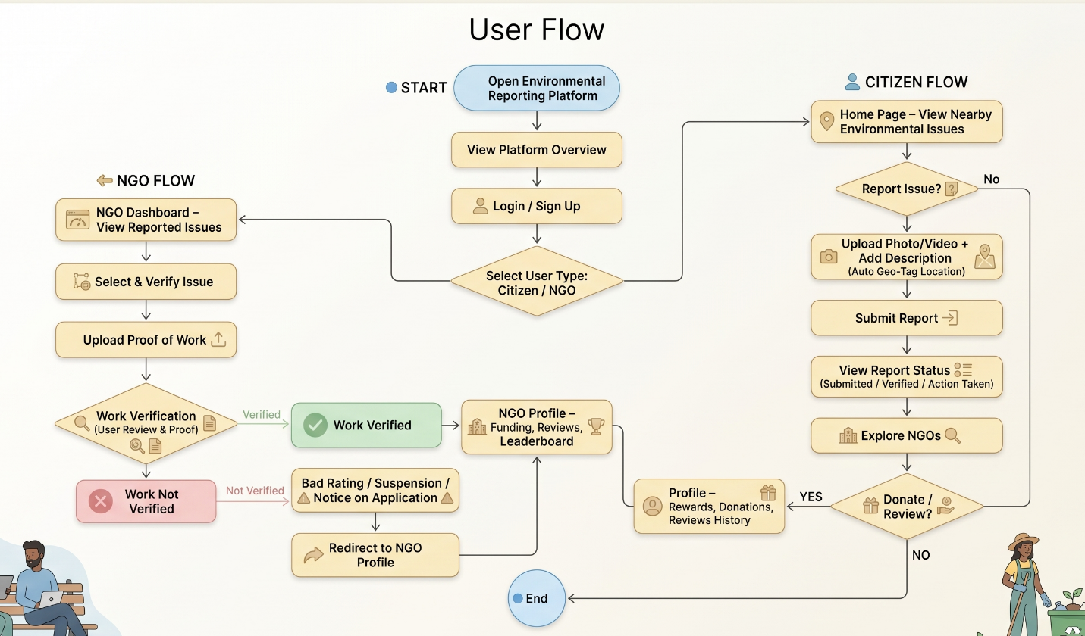

H. COMMERCIALIZATION / MARKET POTENTIAL:
The system is positioned at the intersection of "Smart City" tech and the "Circular Economy". Its commercial viability stems from three main pillars:
- Monetized Civic Engagement: Government and municipal bodies have a high demand for cost-effective ways to monitor their jurisdictions. This platform provides that data through crowdsourcing.
- NGO Revenue Diversification: The marketplace isn't just a shop; it’s a tool for NGOs to reach a motivated, "green-conscious" audience they otherwise couldn't find.
- Scalable Revenue Streams: The platform’s business model is flexible—ranging from micro-commissions on marketplace sales to subscription-based dashboards for private environmental organizations.
I. EXISTING DATA:
No existing dataset has been utilized in the development of the proposed system. The invention is based on real-time, user-generated data, including geo-tagged reports, media uploads, and user interactions within the platform.
All data required for the functioning of the system will be dynamically collected during operation and stored using cloud-based infrastructure for processing and analysis.

4. USE AND DISCLOSURE (IMPORTANT): Please answer the following questions:
- Have you described or shown your invention/ design to anyone or in any conference? | YES () | NO (No)
- Have you made any attempts to commercialize your invention (for example, have you approached any companies about purchasing or manufacturing your invention)? | YES () | NO (No)
- Has your invention been described in any printed publication, or any other form of media, such as the Internet? | YES () | NO (No)
- Do you have any collaboration with any other institute or organization on the same? Provide name and other details. | YES () | NO (No)
- Name of Regulatory body or any other approvals if required. | YES (Yes) | NO ( )

5. Provide links and dates for such actions if the information has been made public (Google, research papers, YouTube videos, etc.) before sharing with us. NA
6. Provide the terms and conditions of the MOU also if the work is done in collaboration within or outside university (Any Industry, other Universities, or any other entity). NA
7. Potential Chances of Commercialization:
The proposed system has strong commercialization potential due to increasing awareness of environmental issues and the growing demand for digital civic engagement platforms. The integration of environmental reporting with an incentive-based model and an NGO-driven marketplace provides both social and economic value.
The platform can be adopted by government bodies, municipal authorities, NGOs, and private organizations for efficient environmental monitoring and community participation. Its scalable design allows deployment from local to national levels, making it suitable for smart city initiatives and sustainability programs.
8. List of companies which can be contacted for commercialization along with the website link.
- Tata Consultancy Services (TCS)
Website: https://www.tcs.com
- Infosys Limited
Website: https://www.infosys.com
- Wipro Limited
Website: https://www.wipro.com
- Reliance Jio Platforms
Website: https://www.jio.com
- Schneider Electric India
Website: https://www.se.com/in/en
- Tata Power – Smart Energy Solutions
Website: https://www.tatapower.com
- Smart City Mission (Government of India)
Website: https://smartcities.gov.in
- SELCO Foundation (NGO)
Website: https://www.selcofoundation.org

9. Any basic patent which has been used and we need to pay royalty to them. NA

10. FILING OPTIONS: Please indicate the level of your work which can be considered for provisional/ complete/ PCT filings (Complete).

11. KEYWORDS:
- Geo-Tagged Environmental Reporting
- Environmental Issue Tracking System
- Smart Civic Engagement Platform
- Incentive-Based Participation System
- NGO-Integrated Marketplace
- Sustainable Product Ecosystem
- Real-Time Issue Reporting
- Environmental Crowdsourcing
- Location-Based Reporting System
- Digital Environmental Monitoring
- Reward-Based User Engagement
- Smart City Environmental Solution

NO OBJECTION CERTIFICATE
This is to certify that University/Organization Name or its associates shall have no objection if Lovely Professional University files an IPR (Patent/Copyright/Design/any other…….) entitled "…………………." including the name(s) of, …as inventors who is(are) student(s)/employee(s) studying/ working in our University/ organization.
Further Name of the University/Organization shall not provide any financial assistance in respect of said IPR nor shall raise any objection later with respect to filing or commercialization of the said IPR or otherwise claim any right to the patent/invention at any stage.

(Authorised Signatory)

